Summative Project: Member Motivations: A Qualitative Study
Colleen M. Steppa
Augsburg College

Abstract
Professional associations serve members to promote personal and professional growth, allow individuals a chance to network and learn about upcoming research in their field, stay involved with trends and skills, as well as provide a sense of community and belonging. Social work professionals employed in group or macro settings have limited options for professional associations that adequately reflect the unique demands of their work, and the International Association of Social Work with Groups, Minnesota Chapter (IASWG-MN) offers training and networking opportunities specifically for group workers. This study, through the use of targeted focus groups, seeks to understand the motivations for membership in professional associations from individuals both within and outside of the social work community, where IASWG-MN recruits for potential new members. This research will add to the body of knowledge on such associations and provide further suggestions for the improvement of associations to ensure thriving membership.
Keywords: membership, groups, social work, associations, motivation

Executive Summary
To Kristen Perron and Amirthini Keefe of IASWG-MN:

The question to be explored in this research is what motivates individuals to join professional associations and rise to positions of leadership in these associations. The scope of the research investigation contained individuals reachable via the LISW & LICSW licensure list that IASWG-MN purchased from the Board of Social Work as well as individuals who voluntarily signed up to be on IASWG-MN’s email list.
The survey utilized was in a qualitative format, and was administered through the use of targeted focus groups. Focus groups were publicized through the use of aforementioned email listserv which is managed through MailChimp, and were attended by five total participants in two groups. Three additional research participants also contributed their data through email as they were unable to attend either focus group and opted out of individual interviews via phone. Research participants were asked their motivations for joining professional associations, accepting positions of leadership within these associations, why they left leadership or membership, and any recommendations they could give to assist associations with recruiting and retaining members.
The most commonly mentioned professional association was the National Association of Social Workers (NASW), with 75% of respondents reporting they were at one time a member, and with twelve total mentions in interviews. This was followed by Association of Macro Practice Social Workers (AMPSW), with 25% of respondents reporting some level of membership, and four mentions, and IASWG, also with 25% of respondents identifying as members at one time, and two mentions.
Analysis of results found that individuals joined professional organizations due to cost-effectiveness, Continuing Education Units (CEUs)/trainings, opportunities for networking, ethnic/social affiliations with the organization, and to purchase malpractice insurance. Those who elected to become leaders in the organizations stated their reasons for doing so were being asked, filling vacancies, desire to change the status quo and positively contribute change to the organization, and feeling the work the association was doing was important. Those who left professional associations as members stated they did so because of high cost, exclusivity, unprofessionalism, poor customer service, and disorganization in the association, with exclusivity as the primary reason with the most overall mentions in focus groups (n = 5). Leaders who left organizations stated overwhelmingly that their reasons for leaving leadership roles were due to feelings of frustration or boredom with the association (n = 8), an unchanging status quo, disorganization in the organization, slow/no progress, lack of accountability, unprofessionalism, and exclusivity.
Recommendations for improving professional associations and encouraging dedicated membership mentioned increasing diversity in recruitment efforts, including starting recruitment efforts at a younger age to increase exposure to the profession, improving the perception of the profession at large, and diversifying board membership. Diversity was commonly mentioned in research interviews, and it was noted repeatedly that authentic, genuine connections with communities of color would be noticed and associations that engaged in open-minded recruitment efforts would have higher levels of success retaining members from all groups. Unconventional methods of searching for board and association membership were recommended to recruit diverse membership.
I would like to sincerely thank Kristen Perron and Amirthini Keefe for making this research possible, and for their support and assistance in recruitment efforts, research organization and presentation of this research. I hope this research is helpful for your association and contributes to IASWG-MN’s mission to improve opportunities for group workers.
Introduction
The International Association of Social Work with Groups, Minnesota Chapter (hereafter referred to as IASWG-MN) seeks to fill a learning need within the social work community for practitioners who specialize in work with groups. IASWG-MN’s mission statement is: “We are a diverse and inclusive collective who value meaningful engagement, global connection and empowerment in groups. We do this through: professional community building, education and training, consultation, and research,” (IASWG-MN, 2008). The group commits itself to providing inclusive educational resources to group workers in Minnesota in diverse roles.
Organizational History and Structure
The International Association of Social Work with Groups (IASWG) is the parent organization of IASWG-MN and began in March of 1979 under the name Association for the Advancement of Social Work with Groups, Inc., or AASWG. (Middleman, 1998.) The association began in a hotel during the Council on Social Work Education (CSWE) Annual Program Meeting in Boston, when a group of social workers noticed that the conference did not have content applying to work with groups and decided to start their own meeting in one of the hotel rooms. Over sixty individuals arrived to the initial meeting and began the first AASWG meeting (Middleman, 1998). The group organized their first symposium of group workers eight months later, a tradition which continues annually and includes group workers from all corners of the globe (Middleman, 1998.) The International Association of Social Work with Groups (IASWG), as it is known today, has over 10 official chapters in the United States, as well as chapters in South Africa, Canada, Germany, and Lithuania, with members from numerous other nations.
The Minnesota branch of IASWG (IASWG-MN) consists of a small working board and a current count of 27 non-board association members. The board of IASWG-MN consists of six members, most of whom are employed in some form of group work. The board positions are as follows: chair, co-chair, membership engagement officer, administrative officer, research intern, communications officer, and treasurer, with treasurer position vacant at the time of this writing.
Agency Demographics
IASWG-MN serves social workers and non-social workers alike who do group work in the Twin Cities area of Minnesota. Membership is open to individuals who are employed in any group work field and there are no specific prerequisites to the definition “group worker”, an intentional ambiguity for increased membership inclusivity. Group workers may be, but are not limited to, licensed social workers, students, faculty in social work bachelor’s or master’s degree programs, or individuals who supervise or receive supervision for licensure. Since IASWG-MN’s primary source of funding is their programming, which awards social work CEUs for participation, those who hold a social work license or are working towards licensure are most highly recruited and stand to reap the highest benefits from membership in the association.

Problem statement
The research question is: what motivates participation and leadership in professional associations? The intent of analyzing this question is to gain insight into how IASWG-MN may better suit the needs and wants of its prospective members in order to build a larger, more engaged membership base. One of the main goals of the organization is to help promote IASWG-MN’s brand and reputation in the community as well as demonstrate the benefits of membership more effectively to members (Smith-Breedlove, 2016).

Literature Review
Existing research on professional associations has found that associations benefit their field by increasing visibility, and benefit members who gain access to publication and dissemination of research (Mata, Latham, & Ransome, 2010). Other benefits of professional association membership include networking, social support and supervision, mentoring, (Walsh & Daddario, 2015) leadership development, and keeping abreast of new developments in technology or best practices (Voigt, 2009). In Voigt’s 2009 article on the values of ITE membership, the three core reasons for involvement in professional associations can be boiled down to knowledge, networking, and leadership (Voigt, 2009).
Knowledge
Professional associations play a role in the legitimization of the field by providing frameworks for practice knowledge and allowing spaces for professionals to publish and distribute their expertise (Greenwood et. al., 2002). Institutional “structuration” is the process of role formalization, creation of communities, and clarification of roles of the varied parts of a disciplinary field (Greenwood et. al., 2002). This process is essential for the organization of a field, which allows for continued growth and professionalism, and is aided by the professional association as a guiding body.
Networking
Involvement in professional associations provides a means for professionals in varied disciplines to meet and assist one another (Voigt, 2009). Aside from the enjoyment that many individual members feel when they are able to connect with like-minded individuals, networking events allow for the free exchange of ideas and practice wisdom, which is highly valued in social work professions where resources may not be centralized. It is especially important for cooperation and networking to occur across disciplines, as it is in these settings where greater growth and knowledge expansion can occur (Bennett, 2010).
Leadership
Leadership in professional associations is a crucial element to overall group success, as evidenced by a study of working groups by Klug & Bagrow. In their analysis of working teams on the platform GitHub, a heavily used software development program where teams can collaborate virtually on projects, Klug and Bagrow found that teams with high levels of success were typically led by a highly successful team member, who was performing a larger share of the workload, and who was typically involved in other, high-success-rate teams (Klug & Bagrow, 2016). Teams with higher levels of diversity were also deemed more successful, and smaller groups were found to have a higher level of individual contributions by team members than larger groups (Klug & Bagrow, 2016).
Motivated and effective leadership is a crucial tool to the success of a team, and certain conditions foster better leadership in associations. In a 2013 survey of Sierra Club chapter leaders, it was found that highly effective leaders had these factors in common: they showed high levels of motivation and investment in outcomes for their branch, they devoted large portions of their time to branch duties, had well-developed skills applicable to their position, and their values had close alignment with their chapter’s cause (Baggetta, et. al., 2013).
Leaders that were part of a more complex organization, with interdependently working teams, equal work shares, and smaller shares of time allotted to meetings were found in general to have higher commitment levels organization-wide (Baggetta et. al., 2013). Researchers hypothesized that, leadership positions require a specific skill set that tends to be found in those individuals who have highly developed skills, are participating in the workforce regularly, and have other learning opportunities available to them (Baggetta et. al., 2013). Given these factors, the ideal leader is likely a person who is employed in the field, has high levels of education, and is well-connected to networks outside of the association, allowing for free exchange of people and ideas.

Research Method
Research Question
The question for research is - what motivates participation and leadership in professional associations?
Research Design
Test subjects were recruited into study via use of the IASWG-MN organizational newsletter. Subjects elected to join one of two focus group times, each subject only being allowed to participate in one focus group time slot. During focus group, participants were asked a series of questions about their motivations for joining and participating in the IASWG as well as their motivations for joining and participating in any other professional associations of which they may be members. Follow up questions were asked depending on the content of conversation, or for purposes of elaboration and clarification.
Other questions in interview include:
-What membership associations are you a part of?
-Why did you initially join these associations?
-If you are still a member, why is that? If not, why did you leave?
-Have you ever held a leadership position in a professional association? If so, why were you motivated to take on this position?
-If you have left a leadership position, why did you do so?
-What could professional associations do to better recruit new members and leaders?
For those subjects who expressed interested in participation in the research project, but had a barrier to participating in the focus groups either due to time or location, researcher offered an option for individual interviews in person or via email for greater convenience. Three respondents chose the latter option to participate via email.
Research Terms
Association – an organized group of professionals that meet on regular basis for training, networking, research, or program development purposes.
Membership – regular participation in an association’s activities, being included on an email or mailing list, paying dues to, or following the activities of an association
Leadership – holding a formal, titled office within an association that contains with it some regular assigned duties, having one’s name listed as contact for a specific purpose or task within the organization, or being named as a leader by other leadership of the association.
Social Work – any employment or volunteer experience within the realm of the helping professions. This includes both licensed and unlicensed workers in a variety of jobs that may or may not have the words “social work” in their title.
Research Population
See Appendix B for IRB approval statement, approval number 2016-141-0. The survey population consisted of individuals on IASWG email listserv, distributed on the MailChimp email marketing platform. This mailing list consists of members who have voluntarily joined the association, have attended IASWG trainings, as well as social workers in Minnesota who have obtained Licensed Independent Social Worker (LISW) or Licensed Independent Clinical Social Worker (LICSW) licensure, whose professional email addresses were purchased from the MN Board of Social Work by the International Association of Social Work with Groups for recruitment purposes. IASWG-MN has permission to use these emails purchased to publicize events and recruit. Individuals were also invited through word of mouth by other IASWG board members, and were also encouraged to tell friends or coworkers. In this way, the research population used a modification of snowball sampling as well as targeted random sampling. Only individuals residing in the Twin Cities metro area over the age of 18 were recruited.
Of the eight research participants, 13% (n = 1) were employed as chemical dependency counselors, 13% (n = 1) retired, 25% (n = 2) employed in education, 25% (n = 2) in macro-practice work and 25% (n = 2) did not specify. Two respondents (25%) self-identified as African-American, the remainder did not self-identify as this question was not explicitly asked.
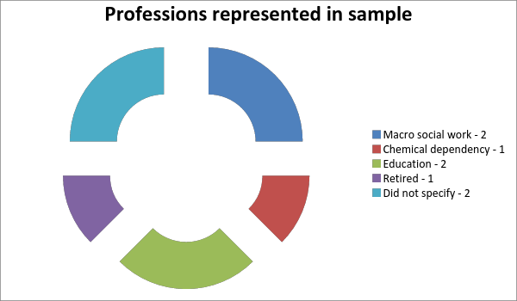
Figure 1. Professions of respondents in research sample.
Measurement instruments
This research was conducted primarily through the use of in-person focus groups. Materials used in focus groups for purposes of data measurement included laptop computer and paper/pen for note-taking purposes, MailChimp email marketing system for distribution of invitation and recruitment materials, and IASWG gmail account for follow-up emails to individual participants. Data coding was conducted with use of pen, paper, and highlighter pens for classification purposes. Data was stored electronically on Google Drive that is password protected for IASWG board use, and stored in paper form. Research participants were offered incentives via a discounted ticket to upcoming training events with IASWG-MN, this message was conveyed via individual emails to each research participant from the researcher’s school Gmail account.

Results
Of the eight participants in the project, three contributed research in email formats rather than focus group, one was the only attendee of their focus group, and four were in the second group together. For the purposes of research coding and due to small sample size, the individual participants and group participants have been grouped together unless otherwise specified. Responses were coded according to frequency that the particular response occurred when specifying motivations for membership and leadership decisions.
Motivations for leadership & membership
When research participants were asked about their membership in professional associations, National Association of Social Workers (NASW) membership was by far the most common, with 75% of respondents (n = 6) stating they had at one time been members of NASW. Of these members, however, only 17% (n = 1) had not allowed their membership to lapse. The one respondent who was still an active member of NASW (ID#8) stated their reasoning for doing so was for malpractice insurance that is cheaper with membership, as they are currently self-employed as an independently practicing social worker.
NASW membership was mentioned by far more often in the course of interviews than any other association, with a total number of 12 mentions by name. The second most commonly mentioned professional association was the Association for Macro Practice Social Work (AMPSW) which had two respondents, (25%) both former members, and a total of four mentions by name. Both former members of AMPSW expressed that they had initially been interested in membership in this association because of the lack of macro offerings found in other social work
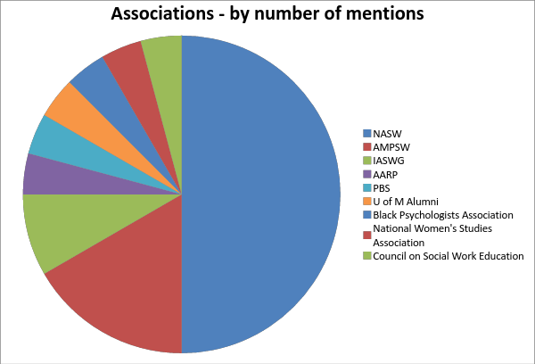
Figure 2. Associations mentioned for former or current membership, by number of total mentions in interviews.
associations. In third place for overall mentions was the International Association of Social Work with Groups (IASWG) which was mentioned twice by name, with two respondents that identified themselves as having some level of membership. Other associations mentioned, at one mention each (13% of respondents, n = 1) included: U of M Alumni association, Black Psychologists Association, Public Broadcasting Service, the American Association of Retired Persons, National Women’s Studies Association, and the Council on Social Work Education.
When asked their initial motivations for joining in their various professional associations, respondents spoke about cost-effectiveness a total of seven times throughout interviews, causing this to be the number one response. Second to this was Continuing Education Units (CEUs) and training, (n = 5) which was often mentioned in close relation to cost-effectiveness as the majority of money spent by members does go toward CEUs and training required for licensure. Cost-effectiveness was mentioned a total of four times by one respondent, making up over half of total responses. Other common responses were networking opportunities (n = 5), ethnic or social affiliations with the membership association (n = 4), and malpractice insurance (n = 2).
Four of eight respondents (50%) reported being at one time in a leadership role in a professional association, though none reported being in a current leadership role. When asked their motivations for initially accepting leadership roles, responses closely mirrored those for joining membership, with two notable differences – respondents reported that cost-effectiveness, CEUs, jobs, training opportunities were important to them as a member of an association, and no items of this type were reported as a decision-making factor in leadership. One factor that was present in deciding to become a leader that was absent from decisions to simply become a regular member was the idea of helping to improve the agency’s functioning from the inside.
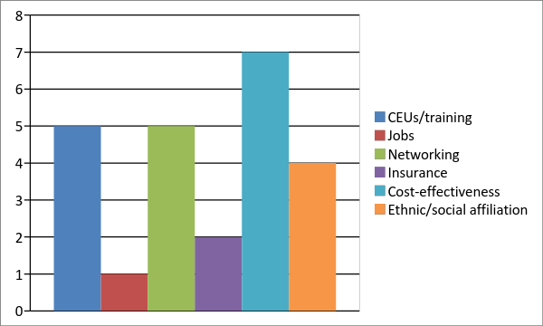
Figure 3. Motivations for membership in professional associations, by number of mentions in interview.
Three of the four respondents (75%) who reported once having a leadership role stated that they took on this role after seeing some issue within the organization they wanted to see remedied or fixed. Respondent #6 reported “I wanted to help the association have a better presence and be more intentional because I felt it was really important work that we were trying to do” (ID #6).
Reasons for leaving associations
Those who left associations as members reported the number one reason for doing so was exclusivity (n = 5) in the member base, which was coded to include responses where members discussed feeling as though they did not belong, noticing cliques, and lack of racial or cultural diversity. The second largest reason listed for leaving membership associations as a member was disorganization (n = 3) with unprofessionalism (n = 2) and high cost (n = 2) at a tie for third place.
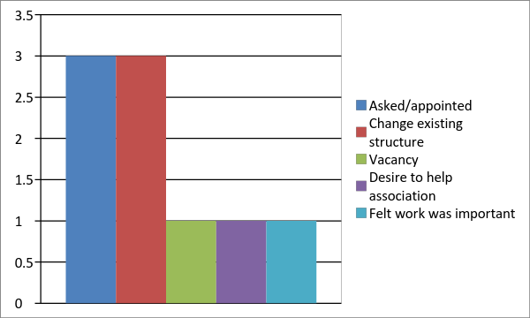
Figure 4. Motivations for entering leadership role within professional association, by number of mentions in interviews.
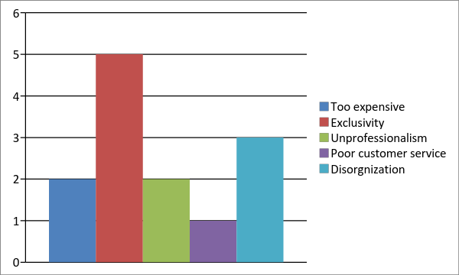
Figure 5. Motivations for leaving non-leadership roles in professional associations, by number of mentions in interviews.
Reports of reasons for leaving professional associations showed similar trends to reasons for leaving leadership roles, with varied prevalence of responses. Motivations for leaving both membership and leadership included unprofessionalism, disorganization, and exclusivity. Those who left professional associations as leaders showed high levels of negative emotions when expressing why they left the association, often describing feeling bored, frustrated, angry, or even used by other leaders in the association. These negative emotional responses were grouped together and formed the number one cause of leaving leadership – frustration and boredom with role (n = 8). Respondent #7 explained her frustration with meetings that seemed to go on without end or purpose, saying, “you’d end up hashing out one thing and then end up hashing it out again months and months later and it’d go on and on. The intention is really good but the organization isn’t there,” (ID#7). Another respondent agreed, adding, “You’d come back after two months and say what have we accomplished?” (ID#6). Other reasons for leaving leadership positions followed a common thread of poor leadership – lack of accountability (n = 4), exclusivity (n = 3), lack of progress (n = 3), and unchanging status quo in organization (n = 3).
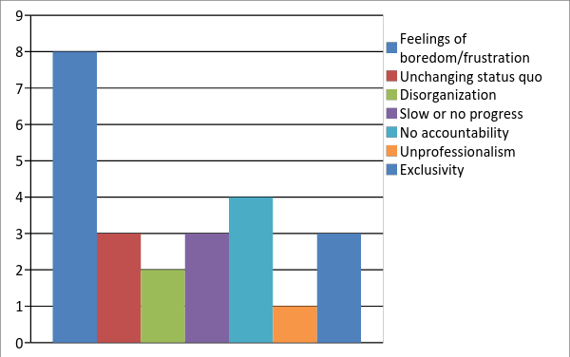
Figure 6. Motivations for leaving leadership roles, by number of mentions.
After exploration of the motivations for joining, leading, and leaving associations, respondents were questioned on ways that associations could improve their membership, better recruit, or increase the buy-in of members to foster greater commitment. The most common response that was expressed was that social work in particular suffers from a professional misconception, and social work associations can improve membership by bettering the perception of the profession, “I think a lot of times people go into social work thinking it’s child protection and mental health, and it’s so much more than that.” (ID #7) It was also discussed that social work as a profession can attract more membership by diversifying its membership intentionally and creating inclusive spaces for people of color, “not just by saying ‘we encourage diverse candidates to apply’ but by considering the nontraditional means of applying,” (ID#7) and recruiting by “going to the people that you don’t normally go to,” (ID#6). It was noted that “social work is and always has been a white woman’s game,” (ID#5) and that social work for communities of color and poverty is often “something that is done TO them, not something people think of being a part of,” (ID#5) with another respondent adding that “when I was working as a paraprofessional I never saw an African American social worker” (ID#4).
Respondent #4, who identifies as an African-American woman, reflected upon her time in undergraduate while she was studying social work. “I had a professor ask us what we were doing in the profession, and I heard a lot of white European women say they were going to “save” the Native American and the African and I was so enraged. I really wanted to hurt that bitch, when she said that she wanted to save the black people. You really need to see who is going into the field because you can do so much harm,” (ID#4). This same respondent reported that, despite being recruited to a degree program in part due to her race, she felt that she was excluded and found it difficult to fit in with others in the program, saying “they wanted me and they recruited me but then when they got me they didn’t know what to do with me” (ID#4).
Several respondents compared the social work profession to others with more successful recruiting efforts, such as STEM (science, technology, engineering, and math) which has successful widespread campaigns to target youth in schools and under-represented populations like women of color to the field. Respondent #6 stated “a lot of this comes down to value. I think about the STEM fields, we are doing this because we see the need here for jobs later on, the problem here is the value systems that are placed around social work… what is the economic focus of what these professions provide? The social benefits get ignored” (ID#6).
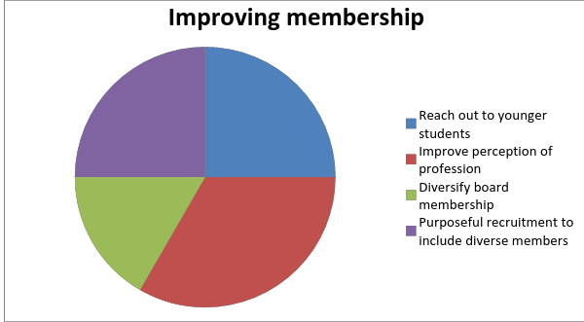
Figure 7. Ways to improve social work associations, by number of mentions in interviews.
Another respondent, who self-identified as an educator, mentioned that social workers lack a union and due to low pay and difficult working conditions, could benefit from unionizing to represent the interests of professionals and protect their employment rights, saying that “teachers unions…have enormous amounts of power in state policies and protect their members from dismissal and as far as I know social workers don’t have anything like that” (ID#5). Another added “I was actually shocked that there was no union for social workers. I felt dismayed; I thought that’s a huge failure of the NASW. We’re working class, some people get rich writing books and travelling the world but most of us don’t… How can we get left out?” (ID #4).
Discussion
Analysis
Respondents did mention themes which were prevalent in the researched literature, such as networking and social connections. Few respondents explicitly mentioned the increased knowledge that can be gained through professional association membership - though trainings were noted as a benefit, these were most often mentioned in the context of CEU requirements for licensure. Overall, interpersonal connections were noted as the highest negative of professional associations while cost for trainings was noted as the highest positive.
Members and leaders both listed exclusiveness as a factor in their decision to leave organization. This was somewhat unexpected given that members did not list inclusiveness or networking in the highest range for originally joining the association, which may suggest that exclusivity has a high negative impact that can outweigh potential benefits of cost-effectiveness or values of training and necessary CEUs. It is notable that in the leader group, those who joined as leaders often expressed a desire to change what they saw were flaws in the organization such as needing a change in structure/status quo, only to leave due to the presence of these same flaws – becoming bored and frustrated in the process.
Leadership success factors that were outlined in the research were the most reflective of the study conducted by Klug and Bagrow, which mentioned several factors of group work that research respondents alluded to as frustrating factors or reasons why they initially engaged as leaders. These research findings noted that highly diverse teams were more successful (Klug & Bagrow, 2016) and interview respondents also emphasized this importance. Furthermore, Klug and Bagrow’s findings suggested that highly successful teams were led by leadership that contributed a higher amount of the work than other team members, and high workloads for leaders was another theme mentioned in research interviews. Other factors in the literature that indicated a propensity for good leadership included high levels of motivation, more time to dedicate towards their leadership tasks, well-developed skills applicable to their position, and has closely aligned values with the cause of the association (Baggetta et. al., 2013). Though respondents reported they were interested in the work that the association was trying to do, there was also prevalent discussion about the low rewards and high stress involved with leadership tasks, so it is possible that these member-leaders were unable to enjoy the benefits of leadership as they had less free time to dedicate to these tasks.
Negative feelings about leadership could be due to the higher level of personal investment involved in leadership, as these members likely had more time and effort involved as a leader than as a member. As Respondent #7 explained, “I organized a training, we did strategic planning, and when there’s no accountability, I felt why am I working so hard? It’s a one-sided effort and people become resentful.” Respondents commented that in a field like social work, where most board positions are unpaid, they felt there were few rewards for leadership work, since “with mission-driven work, you still have overhead, you’re still using your time. You feel like you’re beating your head against the wall. There’s no incentives, not even the feel-good feeling, it wasn’t happening, ever.” (ID #6) Forehand’s research outlines some of the common struggles with group work, citing social dynamics that can hinder good work like social loafing and procrastination (Forehand, et. al. 2016). It is easy to see how leadership may be taxing, especially for unpaid board positions as those described in the focus group interviews.
Limitation of the Focus Group
Through the use of targeted focus groups and interviews, the researcher hoped to gain insight through personal narratives on the sentiments of group members. This method of research was chosen over quantitative measures as qualitative measures may provide better insight into motivations. (Esmaeili, Nayeri, & Negarandeh, 2012). Focus groups allowed individuals to interact and reflect with one another, but this method has certain inherent limitations.
One such limitation is the focus group dynamic with the changes in group member conduct and information gathered due to researcher intervention, intergroup relationships, and other factors that researchers had not intended to be present during the study. (Farnsworth, 2010).The analysis provides a realistic view of how research subjects and moderators are inter-involved - regardless of the ways in which the researcher attempts to isolate variables, it is basically impossible to control all factors involved in the research of human subjects. (Farnsworth, 2010).
Recommendations
Respondents recommended that social work as a profession in particular must pay closer attention to its image from outside the field in order to recruit new, dedicated talent. This demonstrates a disconnect between schools and employers who pay lip service to diverse recruitment but do not actively foster environments for diverse candidates to feel welcomed and thrive.
Aside from encouraging diversity, status-quo thinking and unyielding, overly formal membership organizations appear to be unpopular and will not be successful in recruiting and retaining new members and leaders. Many applications were made to STEM fields as a recruitment model – starting children young to consider careers in the human services or helping professions, in addition to questions about better pay and unions for social workers. Respondents reported feeling that social work had moved away from its radical roots of social activism, citing Jane Addams and the settlement house movement.
Applications
Professional association and other group leaders that wish to diversify and strengthen their ranks would do well to pay attention to cost-effectiveness of membership, inclusiveness, organization, and internal structures that challenge the status quo. Recruitment efforts must go beyond paying lip-service to communities of color and to other differences of gender and social status, because without acknowledging these the field is losing out on valuable contributions from an ever-diversifying workforce.
It is the hope of the researcher that some of the feedback from this study may be applied to bettering the profession of social work, preparing it for the increasing diversity of the field and creating a more inclusive environment in which social work professionals better represent the culture, language, and racial background of the people in the multiethnic groups where social workers are prevalent.

Appendices
Appendix A: References
Appendix B: IRB Approval Letter
Appendix C: Agency Approval Letter – IASWG-MN
Appendix D: Recruitment Posting

References
Baggetta, M., Han, H., Andrews, K. T. (2013). Leading associations: how individual
characteristics and team dynamics generate committed leaders. American Sociological
Review, 78 (4) 544-573.
Bennett, M. H. (2010). The Benefits of Non-Library Professional Organization Membership for
Liaison Librarians. The Journal of Academic Librarianship, 37 (1) 46-53.
Esmaeili, M., Dehghan-Nayeri, N., Negarandeh, R. (2013) Factors impacting membership and
non-membership in nursing associations: A qualitative study. Nursing and Health
Sciences, 15 265-272
Farnsworth, J. (2010). Analyzing group dynamics within the focus group. Qualitative Research,
10 (5), 605-624.
Forehand, J.W., Leigh, K. H., Godsin Farrell, R., & Spurlock, A. (2016). Social dynamics in
group work. Teaching and Learning in Nursing, 11, 62-66.
Greenwood, R., Suddaby, R., & Hinings, C. R. (2002). Theorizing change: The role of
professional associations in the transformation of institutionalized fields. The Academy
of Management Journal (45), 1. 58-80.
IASWG-MN. (2008). IASWG-MN website. Retrieved March 31, 2017, from
http://iaswgmn.org/aaswg/Welcome.html
Klug, M., & Bagrow, J. P. (2016). Understanding the group dynamics and success of teams.
Royal Society Open Science, 3.
Mata, H., Latham, T. P., & Ransome, Y. (2010). Benefits of professional organization
membership and participation in national conferences: considerations for students. MPH
Health Promotion Practice, 11 (4) 450-453. DOI: 10.1177/1524839910370427
Middleman, R. (1998). A Brief History of the AASWG. Social Work With Groups Newsletter,
16 (1) 17. Retrieved from http://www.iaswg.org/our-background
Smith-Breedlove, J. (2016) Thriving professional associations: a needs assessment.
Voigt, K. H. (2009). The Value of ITE Membership. Institute of Transportation Engineers, ITE
Journal, 79 (12) 6.
Walsh, A. M. & Daddario, K. (2015) The dynamic nature of professional associations: factors
shaping membership decisions. Journal of Applied Business and Economics, 17 (3) 115-
119.

Institutional Review Board
Augsburg College
2211 Riverside Ave.

Minneapolis MN 55454

December 8, 2016

To: Colleen Steppa
I am pleased to inform you that the IRB has conditionally approved your application for: “Membership Motivations in Professional Associations—A Qualitative Study”.
Your IRB approval number that should be noted in your written project and in any major documents alluding to the research project is:
2016-141-03

There are two changes that should be made to the consent form and when those have been made please send the updated copy for our files. A telephone number should be included as a contact on the form. In addition the application form directs that three questions shown in Section 11. B. (1) should be included in the consent form.

Your IRB approval expires one year from the date above. The IRB would like to stress that subjects who go through the consent process are considered enrolled participants and are counted toward the total number of subjects, even if they have no further participation in the study. If you desire an increase in the number of approved subjects, you will need to make a formal request to the IRB.

As the principal investigator of this project, you are required to inform the IRB of any proposed changes in your research that will affect human subjects. Changes may not be initiated until written IRB approval is received. Unanticipated problems and adverse events should be reported to the IRB as they occur.

Please inform the IRB of any changes in your address or e-mail.

I wish you success with your project. If you have any questions, you may contact me at IRB@augsburg.edu.

Sincerely,

Milda

Milda Hedblom, Ph.D, J. D.
Augsburg College IRB Chair

Join our focus group!
February 9th, 6:00 - 7:30
1450 West Lake Street
Minneapolis MN 55408
(Uptown Lunds/Byerly's)
We want to hear from you!
You will be assisting an MSW student with graduate research and contributing useful feedback to help IASWG improve the resources we provide. As incentive, you will be offered a coupon for discounted rate at a future IASWG training.
Email steppa@augsburg.edu if you would like to be part of this study! Future time slot is planned if you cannot attend in February.
Focus Group Information

You have been invited to participate in this research study because of your inclusion on our mailing list. Research participants will be asked to attend one group session for an informal discussion of what brings you to IASWG or other professional associations you may belong to. If you are unable to attend these group sessions but would still like to participate, please contact researcher to discuss options for an individual interview.
Your responses will be kept confidential and research will be used to improve the benefits that IASWG provides its member base. These results may be published in a professional journal and presented at a local, state, or national conference. Any identifying information will be removed prior to publishing research to protect the identity of participants and all data will be retained confidentially in a password-protected account. If you have questions about participation in this study, please contact Colleen Steppa at steppa@augsburg.edu.

